CHAPTER TWO

Literature Review

The literature surrounding diabetes prediction through machine learning spans clinical epidemiology, algorithm design, imbalance handling, and model interpretability. This chapter reviews the foundational work in each of these domains, examines the most directly relevant prior studies on diabetes prediction, presents a structured comparative analysis, and identifies the specific gaps that this project addresses.

2.1 Overview of Diabetes and Prediction Systems
Diabetes mellitus sits at the intersection of two rapidly evolving fields: clinical medicine, which has accumulated decades of epidemiological and pathophysiological evidence about the disease and its risk factors, and computational science, which has developed increasingly powerful tools for extracting predictive signal from large-scale health data. Understanding how prediction systems for diabetes have emerged, matured, and been evaluated requires first grounding the discussion in the clinical reality of the disease itself, including its biological definitions, its population-level risk factor architecture, and the historical trajectory that brought computational methods from simple statistical scoring tools to modern machine learning pipelines. The three subsections that follow trace this progression, establishing the clinical and technical context within which the methodology of this project was designed.

2.1.1 Types of Diabetes and Clinical Definitions
Diabetes mellitus is not a single disease but a heterogeneous group of metabolic disorders sharing the defining characteristic of chronic hyperglycemia. The clinical taxonomy recognized by the World Health Organization distinguishes three principal forms, each with a distinct pathophysiological mechanism and epidemiological profile [2].
Type 1 diabetes arises from autoimmune destruction of the insulin-producing beta cells of the pancreatic islets, resulting in absolute insulin deficiency and permanent dependence on exogenous insulin therapy. It represents a small minority of global diabetes cases and typically manifests in childhood or early adulthood [2]. Type 2 diabetes, by contrast, develops through a progressive combination of peripheral tissue resistance to insulin action and a gradual decline in the secretory capacity of the beta cell. It is the dominant clinical form worldwide, accounting for more than 90 percent of all diagnosed cases, and it is distinguished by its entanglement with modifiable risk factors including obesity, physical inactivity, and poor dietary patterns [2], [3]. Gestational diabetes mellitus emerges during pregnancy in women without a prior diagnosis and resolves in most cases following delivery, though it substantially elevates the mother's lifetime risk of developing Type 2 diabetes and carries independent risks for the newborn [2].
The American Diabetes Association's Standards of Medical Care establishes diagnostic thresholds including fasting plasma glucose of 126 mg/dL or higher, a two-hour plasma glucose of 200 mg/dL or higher during an oral glucose tolerance test, or a glycated hemoglobin of 6.5 percent or higher [3]. These thresholds define the point at which the disease is clinically confirmed, but the pathophysiological process leading to them begins years earlier, which is the central argument for prediction-based early intervention [6].
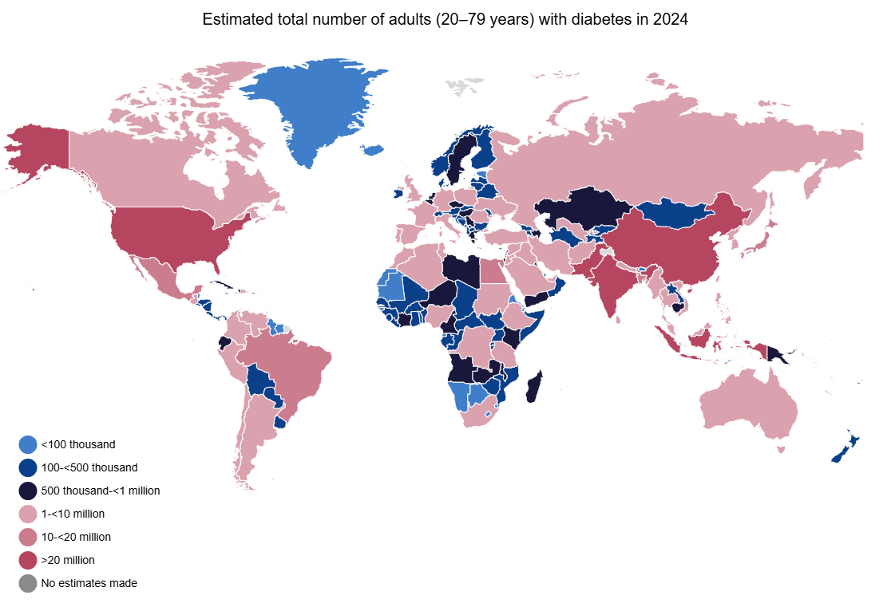

Figure 2.1
Global diabetes prevalence among adults aged 20–79 years, 2000–2050. Source: IDF Global Diabetes Report, 2024 [1].

2.1.2 Risk Factors and Epidemiology
The risk factor profile of Type 2 diabetes is well-characterized and forms the basis for the feature set used in population-level prediction models. Established risk factors include elevated body mass index, physical inactivity, poor diet quality, hypertension, dyslipidemia, a personal history of prediabetes or gestational diabetes, a family history of diabetes, older age, and membership in certain ethnic groups that carry elevated genetic susceptibility [2], [3].
The behavioral and demographic nature of most of these risk factors makes them directly measurable through population health surveys without requiring laboratory tests. The Behavioral Risk Factor Surveillance System, an annual telephone survey conducted by the Centers for Disease Control and Prevention, captures the majority of these risk factors across hundreds of thousands of United States adults, making it one of the most suitable existing data sources for constructing and validating a machine learning-based diabetes prediction system [12]. The preprocessed version of the 2015 BRFSS survey used in this project comprises 253,680 records with 21 health indicator features and a binary diabetes target variable, providing sufficient scale for reliable model training and held-out evaluation [13].
The epidemiological significance of these risk factors extends beyond individual prediction. The modifiability of the majority of Type 2 diabetes risk factors means that accurate early identification of at-risk individuals creates a direct opportunity for prevention, making prediction a clinically actionable step rather than merely a diagnostic formality [6], [3].

2.1.3 Evolution of Diabetes Prediction Systems
The history of computational diabetes prediction systems reflects the broader evolution of medical informatics. Early approaches relied on logistic regression applied to small clinical cohorts, producing models with limited generalizability and sensitivity, particularly in the presence of class imbalance [21]. The introduction of decision tree-based methods improved the interpretability of predictions but did not substantially resolve the generalization limitations of single-model approaches [7].
The subsequent emergence of ensemble methods, particularly bagging and boosting frameworks, marked a qualitative shift in predictive performance. By combining the outputs of multiple base learners, ensemble algorithms achieved systematic reductions in both variance and bias that no single model could replicate, and they introduced natural mechanisms for feature importance estimation that aligned well with clinical reasoning [17], [19]. The arrival of large-scale public health datasets such as the BRFSS provided the data volumes at which these algorithms could realize their full capacity, shifting the focus of diabetes prediction research from small clinical trial datasets toward population-level behavioral survey data [12].
Most recently, the availability of high-level machine learning libraries providing standardized implementations of gradient boosting, cross-validation, oversampling, and model evaluation has enabled researchers to construct and compare end-to-end prediction pipelines with a reproducibility and methodological rigor that was previously difficult to achieve [25], [14]. The present project sits within this most recent generation of work, distinguished by its simultaneous attention to class imbalance, clinical metric alignment, and deployment accessibility [15].

2.2 Machine Learning Techniques in Healthcare
The application of machine learning to healthcare has moved well beyond theoretical demonstration. Across disease classification, risk stratification, treatment outcome prediction, and clinical decision support, data-driven models now operate alongside or ahead of conventional statistical approaches in terms of both predictive accuracy and practical scalability [14]. For chronic disease prediction specifically, the shift toward machine learning reflects a recognition that the relationships between behavioral risk factors and disease outcomes are rarely linear, rarely independent, and rarely well-captured by the logistic regression models that dominated clinical research for decades. This section reviews the algorithmic landscape relevant to the present project, covering supervised learning foundations, ensemble and gradient boosting methods, strategies for handling class imbalance, and the interpretability frameworks that make model outputs actionable in clinical settings.

2.2.1 Supervised Learning for Disease Classification
Supervised learning, in which a model learns a mapping from input features to a target label using labeled training data, is the dominant paradigm in clinical disease prediction tasks [14]. For binary classification problems such as diabetes prediction, the model's objective is to learn a decision boundary that correctly separates positive cases from negative ones across the feature space [21].
Logistic regression has historically served as the standard baseline for binary medical classification, providing interpretable coefficient estimates and calibrated probability outputs. However, its assumption of linearity in the log-odds space limits its ability to capture the complex interaction effects among diabetes risk factors that are known to exist clinically [21]. Support vector machines extend the linear boundary concept through kernel methods but are computationally intractable at the data scales characteristic of modern population health surveys and provide no natural mechanism for probability calibration [7].
The shift toward tree-based methods and their ensembles addressed these limitations directly, enabling non-linear boundary learning, natural handling of mixed feature types, built-in feature importance estimation, and scalability to large tabular datasets [17]. For structured healthcare data, where features represent clinically defined variables with known interactions and non-linear relationships to outcomes, tree-based ensembles have consistently demonstrated superior performance over linear and kernel methods in comparative evaluations [7], [14].

2.2.2 Ensemble Methods and Gradient Boosting
Ensemble methods improve predictive performance by combining the outputs of multiple base learners, reducing the variance and bias that limit individual models. The two primary ensemble paradigms are bagging, which trains base learners independently on bootstrap samples and aggregates their predictions, and boosting, which trains base learners sequentially so that each new learner focuses on the errors of its predecessor [17], [19].
Random Forest, introduced by Breiman, is the canonical bagging method for classification tasks [17]. It constructs an ensemble of decision trees trained on bootstrap samples of the training data with random feature subsampling at each split, producing predictions through majority voting. Its natural feature importance estimates through Mean Decrease in Impurity make it particularly useful for feature selection tasks in medical datasets, as used in this project [17].
Extra Trees extends Random Forests by randomizing not only the feature selection at each split but also the split threshold, further reducing variance at the cost of a modest increase in bias [18]. AdaBoost, the foundational boosting algorithm, iteratively reweights training instances so that subsequent learners concentrate on the cases most frequently misclassified by the current ensemble [20]. Gradient Boosting generalizes this principle by framing sequential learner training as gradient descent in function space, fitting each new tree to the negative gradient of a differentiable loss function [19].
XGBoost extended gradient boosting with regularization terms, second-order gradient statistics, and parallel tree construction, achieving state-of-the-art performance on structured tabular data competition benchmarks [16]. LightGBM subsequently improved upon XGBoost's training efficiency through two novel techniques: Gradient-based One-Side Sampling, which retains only the instances with the largest gradients for tree construction, and Exclusive Feature Bundling, which reduces dimensionality by merging mutually exclusive sparse features [15]. These innovations make LightGBM substantially faster than XGBoost on large datasets while maintaining or improving predictive accuracy, which directly motivated its selection as the primary model in this project [15].
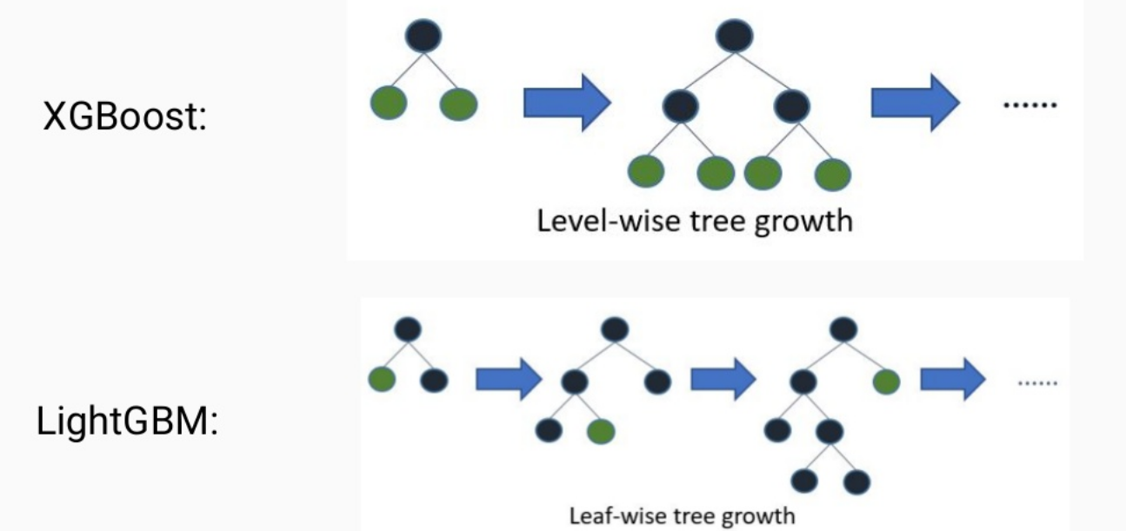

Figure 2.2
Level-wise versus leaf-wise tree growth in LightGBM. Source: Ke et al., NeurIPS 2017 [15].

2.2.3 Handling Class Imbalance in Medical Datasets
Class imbalance is among the most persistent and clinically consequential challenges in medical machine learning. When the positive class, representing the disease of interest, constitutes a small fraction of the training data, standard classifiers are systematically biased toward the majority class, producing high overall accuracy while failing to identify the cases that matter most clinically [9].
He and Garcia provided the foundational theoretical treatment of the imbalanced learning problem, establishing that the root cause of classifier failure under imbalance is not the imbalance ratio itself but the interaction between imbalance, data complexity, and the training objective [9]. Japkowicz and Stephen's systematic empirical study confirmed that this failure mode is consistent across algorithm families and that it grows more severe as the imbalance ratio increases [10].
The primary remediation strategies fall into three categories. Data-level methods resample the training set to reduce the effective imbalance ratio. SMOTE, introduced by Chawla et al., generates synthetic minority class instances by interpolating between existing minority samples and their nearest neighbors in feature space, providing a more informative augmentation than simple random oversampling [22]. Algorithm-level methods modify the training objective directly: cost-sensitive learning assigns higher misclassification penalties to minority class errors, while parameters such as class_weight and scale_pos_weight in gradient boosting frameworks implement this reweighting internally [9]. Evaluation-level methods replace overall accuracy with metrics that correctly capture minority-class performance, including Recall, F1-Score, Balanced Accuracy, ROC-AUC, PR-AUC, and MCC [23]. This project employs all three strategies simultaneously, which the survey literature identifies as the most robust approach to imbalanced medical classification [23].

2.2.4 Explainability and Interpretability in Clinical ML
A prediction model that cannot explain its outputs is of limited clinical utility regardless of its statistical performance. Clinicians require not merely a risk score but a transparent account of the features that drove that score before they can responsibly act on it in a patient encounter [4], [47].
SHapley Additive exPlanations, or SHAP, introduced by Lundberg and Lee, provides the most theoretically principled framework for individual prediction explanation currently available [24]. By assigning each feature a contribution value derived from Shapley values in cooperative game theory, SHAP decomposes any model's prediction into an additive sum of per-feature contributions that satisfies axioms of fairness, consistency, and local accuracy [24]. For gradient boosting models such as LightGBM, SHAP values can be computed exactly using tree-specific algorithms, making them computationally tractable even at large scale [24].
Beyond individual explanations, aggregate SHAP importance plots provide a global view of which features consistently drive model predictions across the population, enabling direct comparison between model-identified risk factors and clinically established risk factor hierarchies. This alignment between model and clinical knowledge is an important validation criterion for any healthcare prediction system [47], [4].

2.3 Review of Previous Studies on Diabetes Prediction
A substantial body of published research has applied machine learning to diabetes prediction across a range of datasets, algorithm families, and evaluation frameworks. Taken together, these studies demonstrate both the feasibility of the approach and the consistency of certain methodological weaknesses that limit the clinical relevance of their results. This section reviews the most pertinent prior works, organized by dataset and methodological focus, to establish the performance benchmarks against which the present project is evaluated and to identify the specific practices that this project improves upon. The review covers studies using the Pima Indians Diabetes Dataset, studies using the BRFSS dataset, studies applying LightGBM and gradient boosting frameworks specifically, and studies that have investigated decision threshold optimization as a deployment consideration.

2.3.1 Studies Using the Pima Indians Diabetes Dataset
The Pima Indians Diabetes Dataset, compiled by the National Institute of Diabetes and Digestive and Kidney Diseases, has served as the most widely used benchmark dataset in diabetes prediction research for several decades. It contains 768 records of female patients of Pima Indian heritage with eight physiological features and a binary diabetes target [7].
The volume of published work on this dataset has produced a thorough empirical characterization of how standard classification algorithms perform on small, imbalanced clinical data. Kavakiotis et al., in a comprehensive survey of machine learning and data mining methods in diabetes research, reviewed over 85 studies and found that classification algorithms were used in 85 percent of cases, with ensemble methods consistently outperforming single classifiers across evaluation metrics [7]. Support vector machines, Random Forest, and naive Bayes were the most frequently applied algorithms, with reported accuracy values ranging from 72 percent to 92 percent depending on the preprocessing strategy and evaluation protocol [7].
However, the Pima dataset's small size, its restriction to a single demographic group, and its exclusive reliance on physiological measurement variables limit its generalizability to population-level screening contexts. The studies reviewed by Kavakiotis et al. also show inconsistent handling of class imbalance and a near-universal reliance on overall accuracy as the primary evaluation metric, which, as established in Section 2.2.3, is an unreliable measure in imbalanced settings [7], [10]. These limitations motivated the present project's choice of the significantly larger and demographically broader BRFSS 2015 dataset.

2.3.2 Studies Using the BRFSS Dataset
The BRFSS dataset represents a more challenging and more clinically realistic prediction environment than the Pima dataset, with a much larger sample size, a broader feature set, and a more pronounced class imbalance reflecting real-world diabetes prevalence [12].
Ullah et al. applied multiple machine learning algorithms to the BRFSS 2015 dataset for diabetes prediction, reporting that traditional screening methods impose access barriers related to cost, infrastructure, and personnel that make population-level application infeasible without computational alternatives [8]. Their analysis confirmed that BRFSS-derived behavioral features carry sufficient signal for reliable risk classification, validating the dataset's suitability for this task [8].
Xie et al. applied Random Forest and support vector machines to the BRFSS 2014 dataset with SMOTE oversampling, achieving competitive predictive performance for Type 2 diabetes risk stratification [27]. Their work demonstrated that SMOTE oversampling improves minority class recall substantially compared to class-imbalance-naive training, a finding that directly informed the imbalance handling strategy of the present project [27].
Li et al. constructed a stacking ensemble combining LightGBM and XGBoost on the BRFSS dataset, achieving a ROC-AUC of approximately 0.96 with SHAP-based feature explanation [26]. This is the most directly comparable published work to the present project and establishes the performance benchmark against which results in Chapter Four are evaluated [26].

2.3.3 Studies Using LightGBM and Gradient Boosting
The body of literature applying LightGBM specifically to diabetes prediction is growing rapidly, with consistently strong results relative to competing algorithms.
Rufo et al. applied LightGBM to a diabetes diagnosis dataset and demonstrated superior classification performance compared to traditional classifiers including logistic regression, decision trees, and naive Bayes, achieving high accuracy with substantially shorter training time than competing ensemble methods [28]. Their work provided the most direct evidence supporting LightGBM selection as the primary algorithm in the present project and serves as a key performance benchmark in Chapter Four [28].
Sai et al. constructed an ensemble of LightGBM and AdaBoost for Type 2 diabetes prediction and demonstrated that the combined model outperformed both individual components across multiple evaluation metrics [29]. The presence of both LightGBM and AdaBoost in the seven-algorithm evaluation framework of this project makes their comparative study a directly relevant methodological reference [29].
The broader gradient boosting literature, anchored by Friedman's foundational theoretical work and extended through the XGBoost and LightGBM frameworks, consistently identifies gradient boosting as the strongest performing algorithm family on structured tabular healthcare data [19], [16], [15]. This consensus directly motivated the decision to prioritize LightGBM in the present project's model selection procedure.

2.3.4 Studies with Threshold Optimization
Decision threshold optimization is among the least consistently applied techniques in published diabetes prediction research, despite its direct clinical relevance. The default classification threshold of 0.50 used in most published work has no clinical justification and produces models whose recall on the minority class is systematically suboptimal [30].
Kopitar et al. conducted one of the most thorough published investigations of threshold optimization for early Type 2 diabetes detection, demonstrating that adjusting the decision threshold beyond the default value substantially improves clinical utility as measured by recall and F1-Score on the diabetic class, without requiring any retraining of the underlying model [30]. Their finding that threshold selection is as consequential as algorithm selection for clinical deployment directly motivated the threshold optimization procedure in Section 3.8.5 of the present project [30].
The Youden index, defined as the threshold that maximizes the sum of sensitivity and specificity, provides one principled criterion for threshold selection in diagnostic contexts [33]. However, in asymmetric clinical settings where missing a positive case carries substantially greater cost than a false alarm, the Youden index is insufficient because it treats sensitivity and specificity as equally important. This project instead implements a recall-constrained threshold selection that identifies the highest threshold satisfying a minimum recall of 0.90, directly encoding the clinical priority into the selection criterion [9], [33].

2.4 Comparative Analysis of Previous Works
The studies reviewed in Section 2.3 share several common methodological features but differ substantially in the degree to which they address the three core problems identified in Section 1.2. The table below summarizes the key characteristics of the most directly relevant prior works.
- Li et al. (2024) [26]: Dataset: BRFSS. Algorithm: LightGBM + XGBoost stacking. Imbalance handling: not explicitly reported. Threshold optimization: not performed. Primary metric: ROC-AUC (0.96). Limitation: no clinical recall constraint applied.
- Xie et al. (2019) [27]: Dataset: BRFSS 2014. Algorithm: Random Forest, SVM. Imbalance handling: SMOTE. Threshold optimization: not performed. Primary metric: accuracy and AUC. Limitation: no threshold optimization, accuracy-centric evaluation.
- Rufo et al. (2021) [28]: Dataset: clinical diabetes dataset. Algorithm: LightGBM. Imbalance handling: not reported. Threshold optimization: not performed. Primary metric: accuracy. Limitation: small dataset, no imbalance strategy, default threshold.
- Sai et al. (2023) [29]: Dataset: standard benchmark. Algorithm: LightGBM + AdaBoost ensemble. Imbalance handling: not explicit. Threshold optimization: not performed. Primary metric: accuracy and F1. Limitation: no recall constraint for clinical deployment.
- Kopitar et al. (2020) [30]: Dataset: electronic health records. Algorithm: multiple classifiers. Imbalance handling: class weighting. Threshold optimization: performed. Primary metric: AUC and recall. Limitation: no composite scoring for model selection.
- Ullah et al. (2022) [8]: Dataset: BRFSS 2015. Algorithm: multiple classifiers. Imbalance handling: partial. Threshold optimization: not performed. Primary metric: accuracy. Limitation: accuracy-centric evaluation, no threshold tuning.
The pattern across these studies is consistent: each addresses one or two of the three core problems identified in this project but none addresses all three simultaneously within a single reproducible pipeline. Imbalance is either ignored or addressed only at the data level. Threshold optimization is the least commonly applied technique despite having the most direct impact on clinical recall. Evaluation frameworks remain predominantly accuracy and AUC-centric, which are insufficient metrics in the presence of class imbalance [31], [32]. The composite scoring function, three-layer imbalance strategy, and recall-constrained threshold optimization of the present project collectively address all of these gaps.

Table 2.1
Methodological characteristics of selected prior studies on machine learning-based diabetes prediction.
Study | Dataset Size | Feature Engineering | Validation Strategy | Deployment | Research Gap Addressed
Li et al. 2024 [26] | Large (BRFSS) | Not reported | Not reported | Not reported | Ensemble stacking
Xie et al. 2019 [27] | Large (BRFSS 2014) | None | Train-test split | Not reported | SMOTE oversampling
Rufo et al. 2021 [28] | Small (clinical) | None | Cross-validation | Not reported | LightGBM vs traditional
Sai et al. 2023 [29] | Benchmark | None | Train-test split | Not reported | Ensemble combination
Kopitar et al. 2020 [30] | Medium (EHR) | None | Cross-validation | Not reported | Threshold optimization
Ullah et al. 2022 [8] | Large (BRFSS 2015) | None | Train-test split | Not reported | Behavioral features
Kavakiotis et al. 2017 [7] | Multiple | None | Varied | Not reported | Survey of methods
Ismail et al. 2022 [34] | Multiple | None | Varied | Not reported | Review of gaps
This Study | Large (BRFSS 2015) | 21 → 45 features (24 engineered) | Stratified 5-Fold CV | Streamlit web app | All five gaps simultaneously

2.5 Identified Research Gaps
The review of the literature reveals five specific gaps that the present project directly addresses.
Gap 1: Absence of simultaneous multi-layer imbalance handling
The majority of reviewed studies apply at most one imbalance mitigation strategy, typically either data-level oversampling or algorithm-level cost weighting, but rarely both in combination with evaluation-level metric selection. Ismail et al. confirmed in a comprehensive review that this fragmented approach is the norm and that it systematically underestimates the recall achievable on the diabetic class [34]. This project applies all three layers simultaneously.
Gap 2: Absence of clinically motivated threshold optimization
With the exception of Kopitar et al. [30], none of the reviewed BRFSS-based studies performs systematic decision threshold optimization. Deploying a model at the default threshold of 0.50 without evaluation across the full probability range ignores the clinical asymmetry between false positive and false negative errors that is central to the value of a screening system [33], [9].
Gap 3: Accuracy-centric evaluation frameworks
The majority of reviewed studies report overall accuracy as the primary performance metric. In datasets with a 6.1 to 1 class imbalance ratio, accuracy is dominated by majority-class performance and provides no meaningful information about the model's ability to identify diabetic cases [10], [31]. Clinically appropriate evaluation requires Recall, F1-Score, Balanced Accuracy, PR-AUC, and MCC as the primary reporting metrics, which this project adopts exclusively [44], [32].
Gap 4: Lack of domain-informed feature engineering on the BRFSS dataset
The reviewed BRFSS-based studies predominantly use the 21 original survey features without systematic domain-informed engineering. The present project introduces a 45-feature engineered space incorporating WHO clinical thresholds, composite risk scores, and interaction terms, producing measurable discriminative improvements across all seven evaluated algorithms [37], [17].
Gap 5: Absence of end-to-end reproducible deployment pipelines
None of the reviewed studies packages the trained model, preprocessing components, and threshold configuration into a unified deployment artifact accessible to clinical practitioners without programming expertise. The Streamlit-based pipeline bundle of this project directly addresses this gap, providing a practical demonstration of research-to-deployment translation [5], [11].

2.6 Chapter Summary
This chapter reviewed the theoretical and empirical foundations underlying the Smart Diabetes Monitoring and Prediction System across four interconnected domains. The clinical epidemiology of diabetes mellitus established the medical urgency of early detection, with the global burden of 537 million cases and the preventable nature of most complications confirming that timely prediction carries direct clinical value [1], [2], [3]. The survey of machine learning techniques in healthcare demonstrated that gradient boosting frameworks, and LightGBM in particular, consistently outperform competing approaches on structured tabular clinical data, while also identifying class imbalance, threshold selection, and evaluation metric design as the three most consequential methodological challenges in this domain [4], [15], [9]. The review of prior studies on the BRFSS dataset revealed that most existing work optimizes for overall accuracy at the default threshold of 0.50, fails to implement multi-layer imbalance handling, and does not report Recall as a primary deployment criterion [8], [27], [34]. These observations collectively defined five research gaps that the methodology of this project is specifically designed to address, establishing the direct motivation for every design decision documented in Chapter 3.

